|  |  |  |  |
| --- | --- | --- | --- |
| Student Name | Angela Peng | Date: |  |
| Student ID | C15402002 | Supervisor: | Dr. Oisin Creaner |

CHALLENGES:

<Describe the challenges you faced this week in your FYP, and/or describe any challenges that you have overcome from last week, and explain how you solved the problem.>

ACTION ITEMS:

<insert a bullet point list of your action items for this week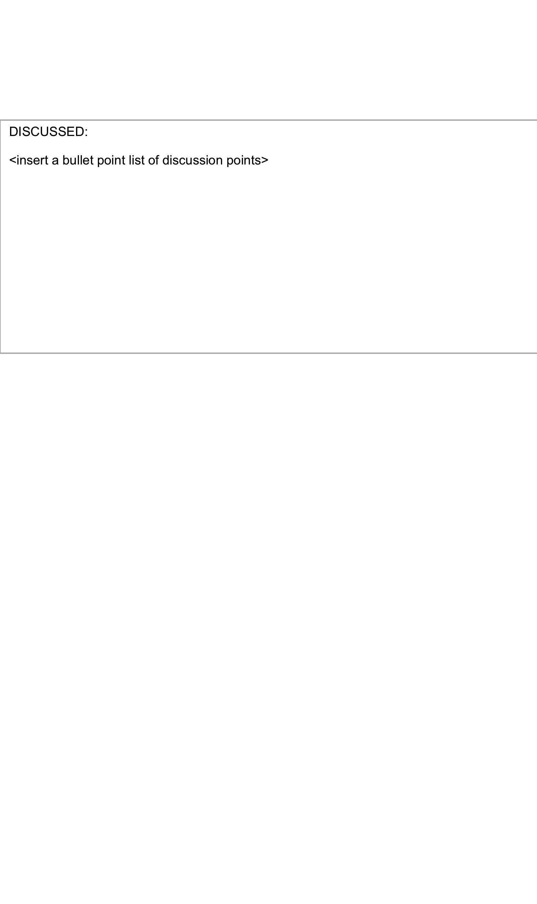>

DISCUSSED:

DON’T be afraid to talk about the future plans

<insert a bullet point list of discussion points>

* Erd
* Normalization

Sel out the premise

Why would customers want this

Market? Refernces!

Talk about the method technical architecture/data/use case methology

App -> qr code -> server -> kitchen several front end

Server on laptop

Virtual inforstructure

My sql server

User interaction/tests

Conclusioln Meaning of results, future plans, gantt chart, timeline